The current design for the new Bob Hall Pier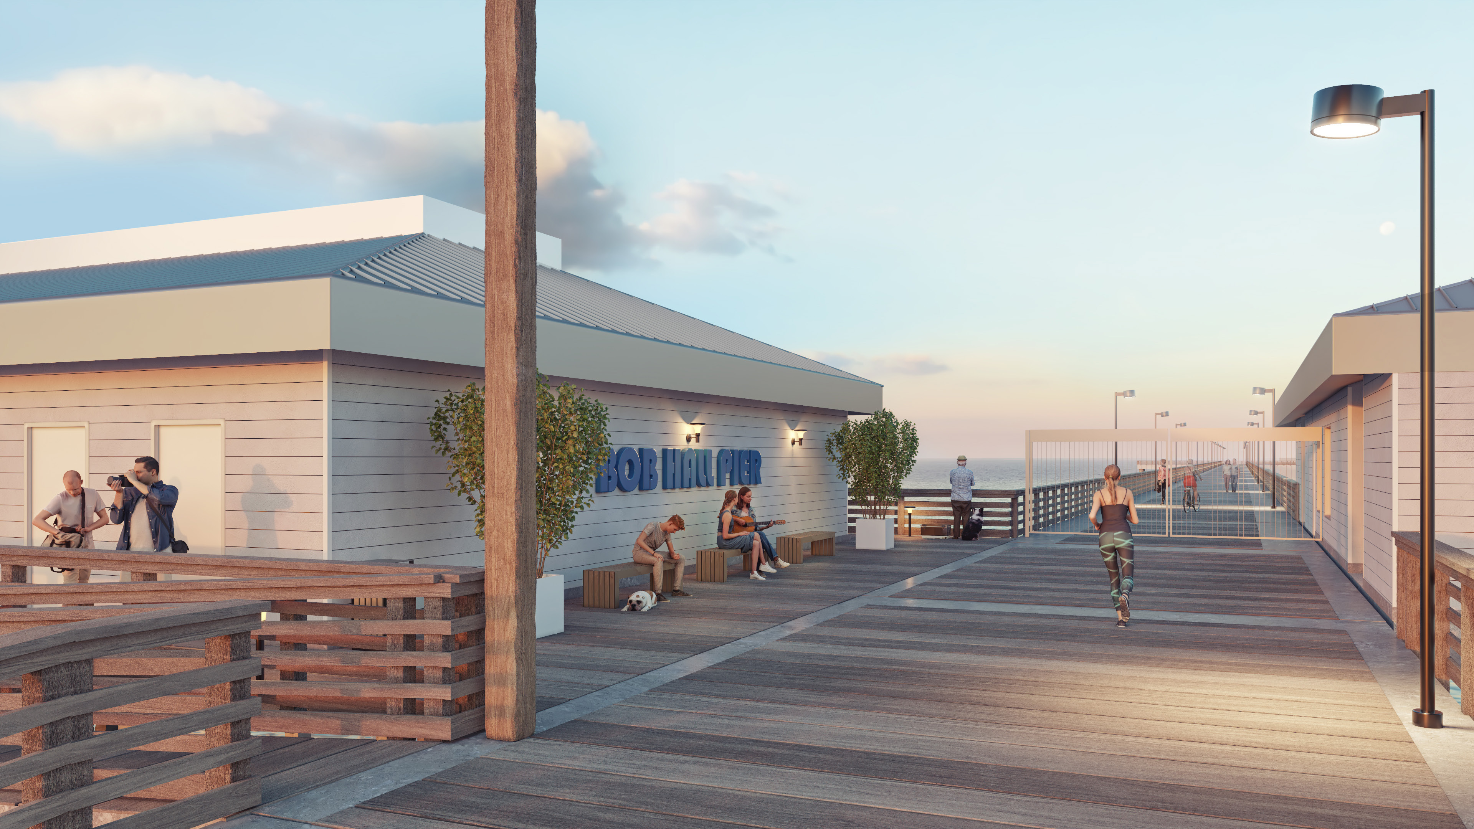 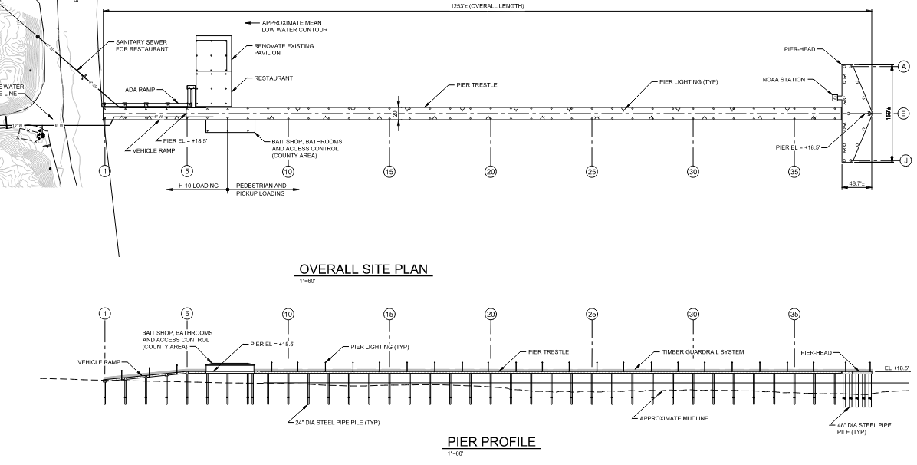 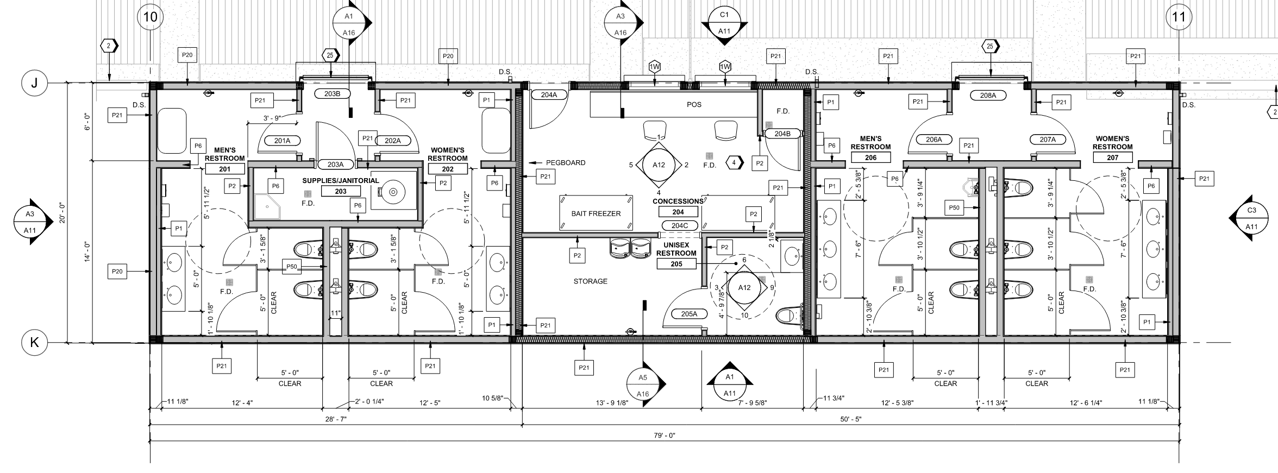Public Restroom
• 2 mens & womens toilets
• Janitor closet
• Baby changing tables
Pier Restroom
• 2 mens toilets & 1 urinal
• 3 womens toilets
• Baby changing tables

